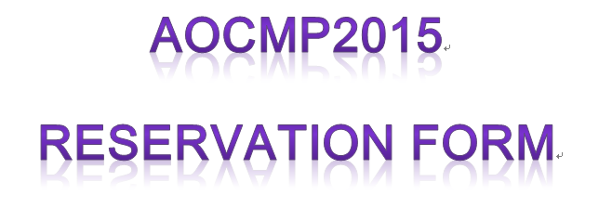
Please email this form to the hotel (rsvn.xian@kempinski.com) to book your room.

Hotel Name | Rating | Room’s type | Room rates (RMB)
Kempinski Hotel Xi’an | 5 | Deluxe Room | 550

Full Name:
Passport No./ID No.
E-mail:
Phone Number:
Hotel Name:
Number of Rooms:
Check in date:
Check out date:
Other Requirements:

